1. Right click on specific field >> inspect >>click on that highlighted line >> click Cntrl+f
2. Now // (because xpath start with //) then check html input
3. Check always it must 1of1 in serch refer below diagram it means exect location is selected.

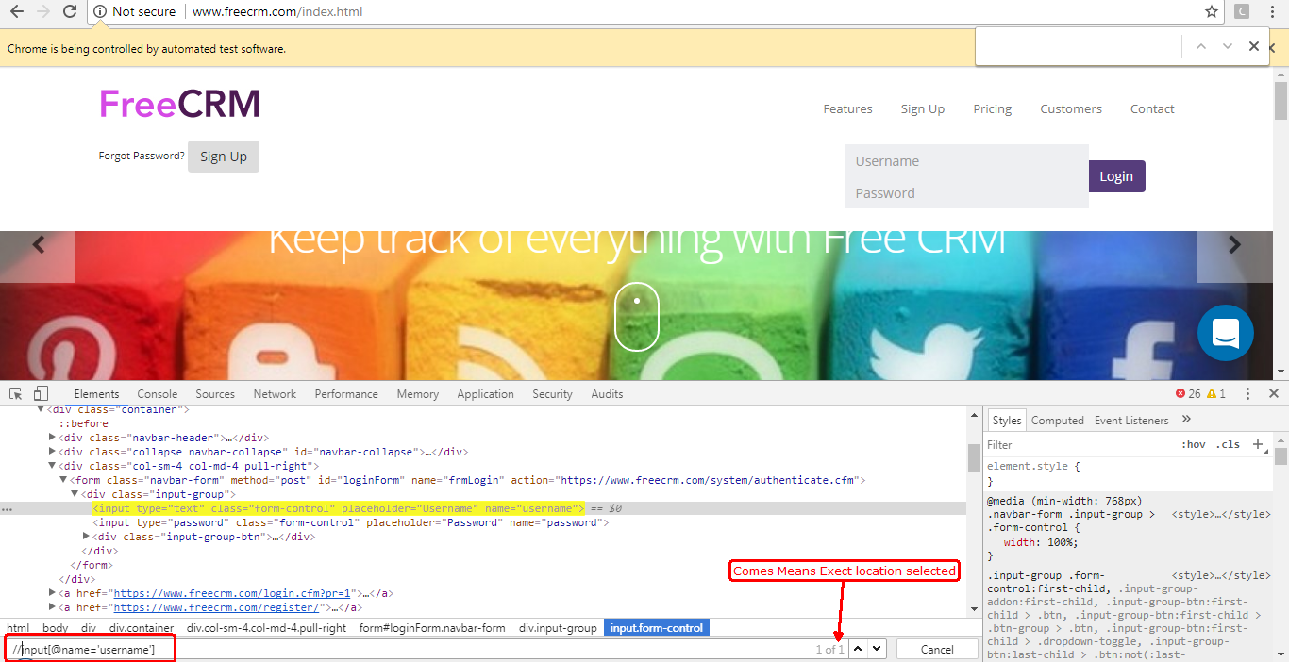

1. To make certain field more exact we can use simply and operator also.

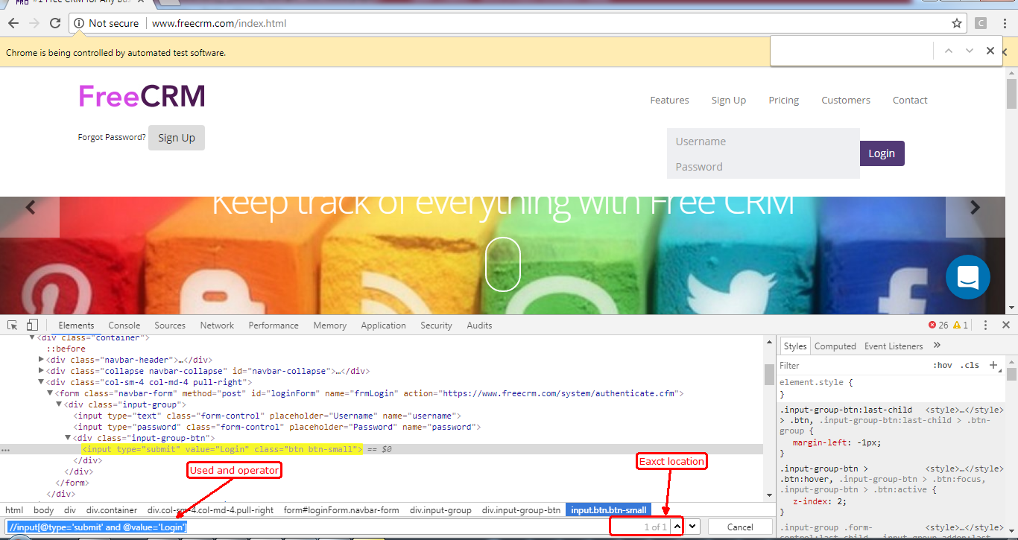

1. This Xpath Values are case sensitive means if the value is=’Login’ and we write login then it will not detect as L is not capital.
2. How to Inspect Links by Text().

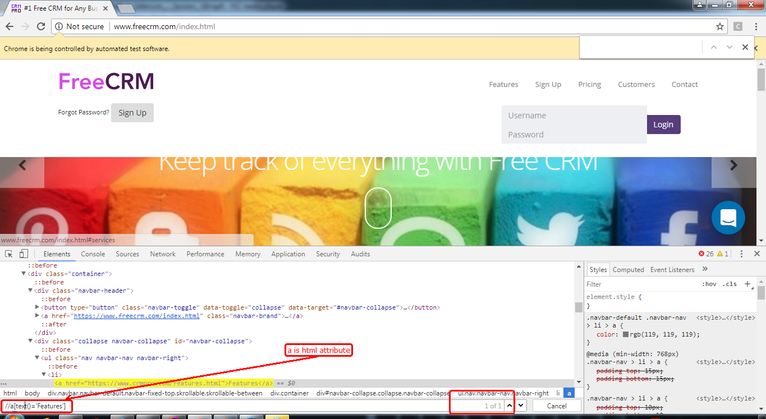

1. Second Way to write Xpath for Links.

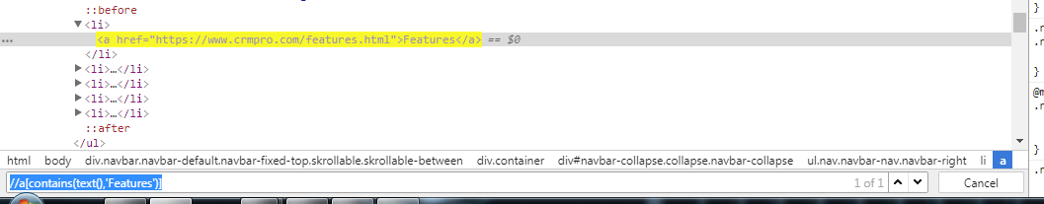

1. Button

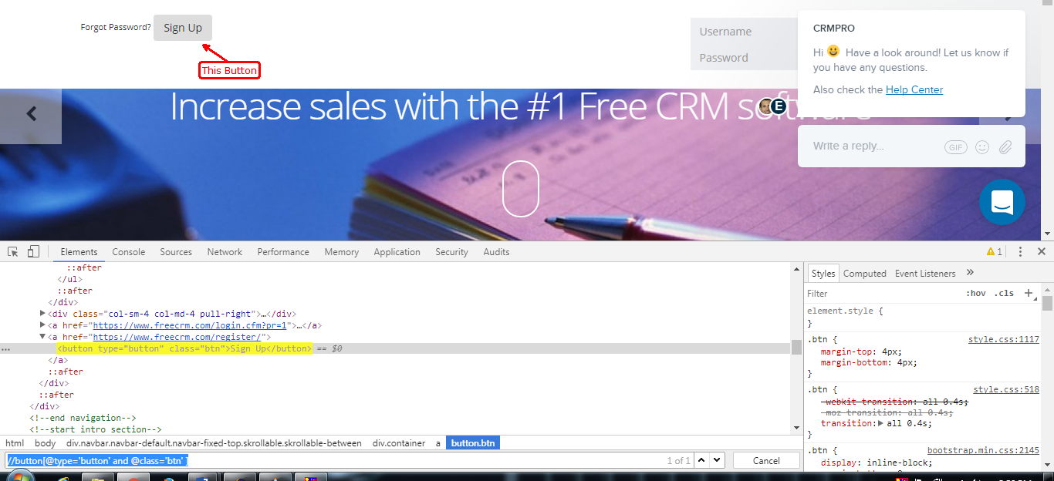

1. Another way to inspect button using Inspect.

